Reference information provides the title and authors of an article, the name of the journal where it was published and when it was published, as well as the page numbers of the article. You need reference information when writing your thesis or other work where you cite someone else's work. With the help of references, you will be able to create citations and a bibliography.

It is important to be able to read reference information to find the information you need to cite your sources. Additionally, references identify an article so that the reader will be able to search for it in the library, for example.

NOTE: There is a difference between reference information and availability information. Information on availability lets you know which library or database has the item on hand. 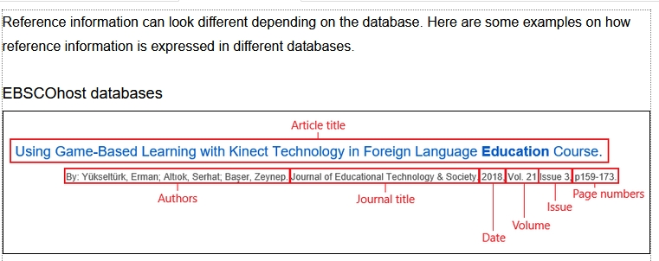

Article references often use these terms:

* **Authors**: Name of the author or authors. The names of the authors can be written differently in different referencing styles, e.g: surname, first letter of given name. The abbreviation *et al.* sometimes added after names of authors means that there are more authors to the work than mentioned in the citation. Articles are published in journals as well as edited books. An edited book consists of articles or chapters written by several authors.
* **Title**: The title of an individual article. A journal or an edited book consists of separate articles. Always notice the difference between the title of the article and the name of the journal or edited book where the article was published.
* **Journal** (magazine, publication): The name of the journal, magazine, or publication where the article was published.
* **Date** (year of publication): The year when the article was published.
* **Volume** (vol.): Typically, a volume consists of journal issues published within a year. The volume number often indicates the number of years the journal has been published. For instance, the issues of 2017 of a journal begun in 2010 would be part of the seventh volume. However, volumes do not always follow calendar years and some journals there may have several volumes published within a year.
* **Issue** (number, no): Each publication within a volume is an issue. The issue number can be written in parentheses after the volume number, e.g. *Vol. 17(42)*.
* **Pages** (p., pp.): The page numbers of an article within an issue. Page numbers are given from the first page of the article to the last, e.g. *pp. 133-137.* The numbering can continue from one issue to the next throughout a volume.



**Downloading and Installing Zotero:**



**Link:**

<https://www.zotero.org/download/client/dl?channel=release&platform=win-x64&version=7.0.11>

**Zotero Connector for Firefox**

<https://www.zotero.org/download/connector/dl?browser=firefox&version=5.0.147>

**Zotero Connector for chrome**

<https://chrome.google.com/webstore/detail/ekhagklcjbdpajgpjgmbionohlpdbjgc>

**Zotero Style Repository**

**Link:**

<https://www.zotero.org/styles>

Example:

Poultry Science

the chicken was domesticated in China about 6000 BC and spread into Europe via Russia.(Serin et al., 2017; Cheng et al., 2021; Abbasabadi et al., 2024)

The domestication of chickens began in China around 6000 BC and they later spread into another countries.

References

Abbasabadi, H., M. R. Bakhtiarizadeh, M. H. Moradi, and J. C. McEwan. 2024. RNA-Seq based selection signature analysis for identifying genomic footprints associated with the fat-tail phenotype in sheep. Front. Vet. Sci. 11 Available at https://www.frontiersin.org/journals/veterinary-science/articles/10.3389/fvets.2024.1415027/full (verified 8 December 2024).

Cheng, B., L. Leng, Z. Li, W. Wang, Y. Jing, Y. Li, N. Wang, H. Li, and S. Wang. 2021. Profiling of RNA N 6-Methyladenosine Methylation Reveals the Critical Role of M6A in Chicken Adipose Deposition. Frontiers in Cell and Developmental Biology 9:590468.

Redding, R. W. 2015. The Pig and the Chicken in the Middle East: Modeling Human Subsistence Behavior in the Archaeological Record Using Historical and Animal Husbandry Data. J Archaeol Res 23:325–368.

Serin, E. A. R., L. B. Snoek, H. Nijveen, L. A. J. Willems, J. M. Jiménez-Gómez, H. W. M. Hilhorst, and W. Ligterink. 2017. Construction of a High-Density Genetic Map from RNA-Seq Data for an Arabidopsis Bay-0 × Shahdara RIL Population. Front. Genet. 8:201.